**Meeting with Minister of Foreign Affairs Najla El Mangoush**

**Scene Setter:**

*This is your first real meeting with* ***Najla El-Mangoush****. You only just saw her 2 minutes in Istanbul.*

*A lawyer from Benghazi (East), without a limited political background, she was appointed foreign minister by PM Dbeibah on 15 March 2021 after his first choice was rejected by the Easterners.*

*Difficult to understand clearly her real influence in the Government as well as her relations with the Eastern leadership. However, the minister has been expressing publicly a determined position on the need for a rapid* ***withdrawal of foreign fighters and mercenaries****.**For this she was clearly put under threat by pro-Turkish elements in Tripoli in May. The Minister would currently be* ***working on a Libyan-led proposal*** *for the withdrawal. She was in Moscow in August to discuss the issue with Lavrov and recently also approached Cairo. The EU has not been officially informed until now the impression is that for the moment there are not many details. It is even impossible to understand whether this initiative is coordinated with the French Non-Paper.*

*In an attempt to shift the centre of gravity of the discussion from Berlin and UNSMIL efforts, she (with the backing of the PC Mnefi) is also trying to push for a “****Libya Stability Initiative****” (a paper was given to a limited number of participants at the Berlin conference in June see it in annex) and* ***wants to organise a Conference late September*** *with most Berlin Participants.* ***The EU has been excluded so far.***

*Minister El-Mangoush was also the first Libyan official to speak out about the**need for* ***“stability and security before the elections”,*** *thereby suggesting that elections could be postponed****.*** *She reiterated a similar position at the consultative meeting of Ministers of Foreign affairs of the neighbouring states of Libya organised by the Algerian FM Lamamra on 30 and 31 August.*

*The minister was already involved in discussions with Commissioner Varehlyi last spring. She tends to be very critical of the EU’s migration policy.*

**General**

* Happy we can finally meet. Libya is at a critical stage and we hope to see the achievements of the past year consolidated. This is a **real opportunity to** steer the country towards **stability and peace**.
* Fully conscious of the many structural challenges that the government continues to face and I am here to understand from you and the Prime Minister **how the EU can help more**.

**On the follow up of Berlin**

* In Berlin in June we all agreed on **two crucial commitments**:   
  1. Implementation of the agreed Roadmap and **elections on 24 December**;   
  2. Full implementation of the ceasefire agreement and **withdrawal of all foreign forces**.
* I saw your message on elections, including last week at the meeting of Libya’s neighboring countries in Algiers. We are hearing the declaration from the Speaker of the Parliament, don’t you think that there would be a **risk for the legitimacy of the process if elections are postponed?** Maybe let the Libyans choose their next leaders in December would be the only safe way.
* **On the security front,** the reopening of the Misrata-Sirte Coastal Road was a very positive development. Happy that the EU will deliver concrete support to the newly established **Joint Police Force**.
* Where do you stand on **withdrawal of all foreign forces**?I understand that **you are working on this issue**? Can you share your ideas? Can the EU help?

**On the MFA Mangoush’s “Libya Stability Initiative”**

* I also heard of **your** **Stability Initiative** and understand that you are planning to hold **a conference** in September**.** We would be interested if you could share some details and we are very keen to support any Libyan led efforts which would be in line with Berlin and UN efforts.

**On the economy**

* Libya still has **no budget for 2021** and I heard your emphasis on economic aspects in Algiers last week. As co-chairs of the Economic Working Group, the EU, together with the US and Egypt, have done their best to bring the parties together. What is the situation and what more could we do to unlock the situation?

**On cooperation with the EU**

* The EU has done a lot in Libya so far, and as I will explain to PM Dbeiba, **we are ready to do more** on the basis of your needs and priorities.
* We want Libya to become a full partner of Europe, fully associated to the European Neighborhood Policy,like the other countries of the region. This is also why we were among the first to reopen our diplomatic mission in Tripoli and send our Ambassador back.
* I will make an offer of serious support for State building and upgrade of the administration to the Prime Minister. And we are ready to deploy expertise quickly if Libya is interested. Ultimately, we hope that the conditions will be reunited soon to start negotiating an **Association Agreement** between the EU and Libya.

**On Migration**

* As my colleagues Commissioners Vareylyi and Johansoon indicated when in Tripoli, we want migration to be a **part of the much broader agenda**. And we want to address our joint challenges for the benefit of both sides and in full respect of human rights.
* You know our longstanding support to the work of UN agencies that conduct **voluntary returns, evacuation and resettlement** from Libya. We count on your support for evacuating the most vulnerable people from Libya and providing a humanitarian corridor responding to the urgent needs of these persons.
* As you know, the bulk of our assistance to Libya comes through Libyan and International NGOs. Current Libyan regulations **restrict engagement of NGOs** with any foreign entity. This makes it very complicated for us to operate. The EU is ready to assist the Libyan government in revising these rules so that they meet international standards.
* Also, we need to continue efforts on protecting the rights of migrants and people in need of international protection. The end of the **arbitrary detention system** and the inhumane conditions in **detention centres** must be ensured and we stand ready to support you in this.

* We will relaunch the **Tripartite cooperation** [EU/UN/AU] to have a more global picture and better coordinate with the other African countries.
* We understand the importance for Libya of the control of southern borders. The proposal to reactivate the agreement signed with Chad, Sudan and Niger in 2018 is very useful. Do you think the **EU can help with this regional approach**?

**On Tunisia**

* As a neighbour, I’m sure that you are following very carefully the developments in Tunisia. Which are your views from here? Do you believe that the current situation could have any influence on Libya’s?

**Najla Mohammed El Manqoush, 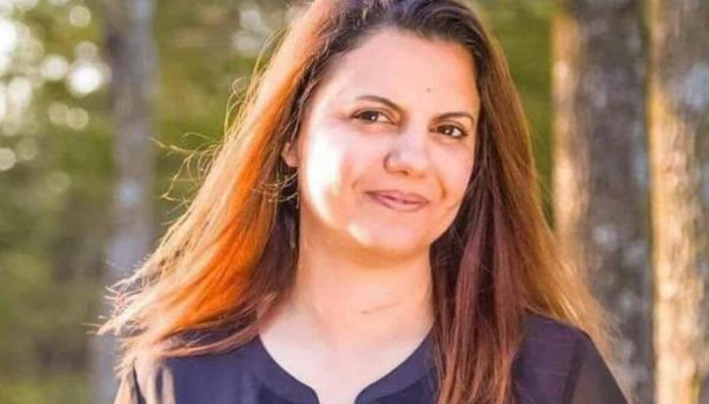Minister of Foreign Affairs**

El Manqoush has been Foreign Minister since 15 March 2021. She is Libya's first female Foreign Minister.

Born in Cardiff, Wales, she moved back to Benghazi with her family when she was six years old. Trained as a lawyer at Benghazi University, she headed the National Transitional Council’s Public Engagement Unit during Libya’s 2011 revolution, dealing with civil society organisations. She was subsequently a Fulbright Scholar in the US. She received an MA in Conflict Transformation from the Center for Justice and Peacebuilding at EMU university in Virginia and has a PhD in conflict analysis and resolution from George Mason university.

She was the country representative in Libya for the United States Institute of Peace. She is a native Arabic speaker fluent in English.