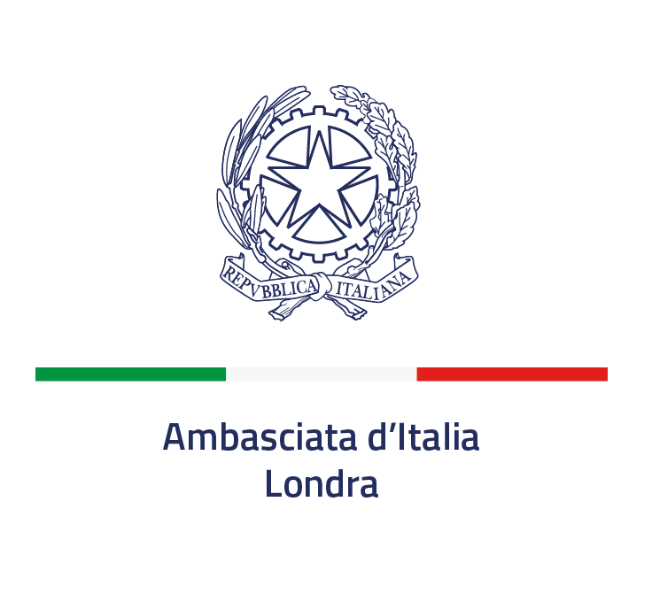

**Virtual Roundtable on** “**Libya – Charting the Way Forward”**

(18 March, 16:00-17:30 GMT)

* Mr Emadeddin Badi (senior analyst, Global Initiative against Transnational Organized Crime) <https://globalinitiative.net/profile/emadeddin-badi/>
* Mr Tim Eaton (senior research fellow, Chatham House) <https://www.chathamhouse.org/about-us/our-people/tim-eaton>
* Mr Ben Fishman (senior fellow, Washington Institute for Near East Policy) <https://www.washingtoninstitute.org/experts/ben-fishman>
* Ms Mary Fitzgerald (associate fellow, International Centre for the Study of Radicalisation ) <https://mary-fitzgerald.com/>
* Dr Wolfram Lacher (senior associate, German Institute for International and Security Affairs - SWP) <https://www.swp-berlin.org/en/scientist-detail/wolfram-lacher/>
* Mr Tarek Megerisi (policy fellow, European Council on Foreign Relations) <https://ecfr.eu/profile/tarek_megerisi/>
* Mr Karim Mezran (resident senior fellow, Atlantic Council) <https://www.atlanticcouncil.org/expert/karim-mezran/>
* Dr Tarik Yousef (senior associate, Brookings Doha Center) <https://www.brookings.edu/experts/tarik-yousef/>
* Mr Raffaele Trombetta (Italian Ambassador in London)
* Mr Pasquale Ferrara (Special Envoy of the Italian Ministry of Foreign Affairs for Libya)
* Mr Giuseppe Buccino (Italian Ambassador in Tripoli)
* Mr Luca Gori (MENA Director, Italian Ministry of Foreign Affairs)
* Mr Andrea Catalano (Maghreb Team Leader, Italian Ministry of Foreign Affairs)
* Mr Gianluca Brusco (Head of the Political Office, Italian Embassy in London)
* Mr Alberto La Bella (Head of Press and Culture, Italian Embassy in London)
* Mr Andrea Marchesetti (analyst, Italian Embassy in London)