**- EUROPEAN UNION LIAISON AND PLANNING CELL LIBYA -**

**EULPC WEEKLY Report, 21 January 2020**

UNOFFICIAL

**1. General remarks and current tactical situation**

**2. Update military events**

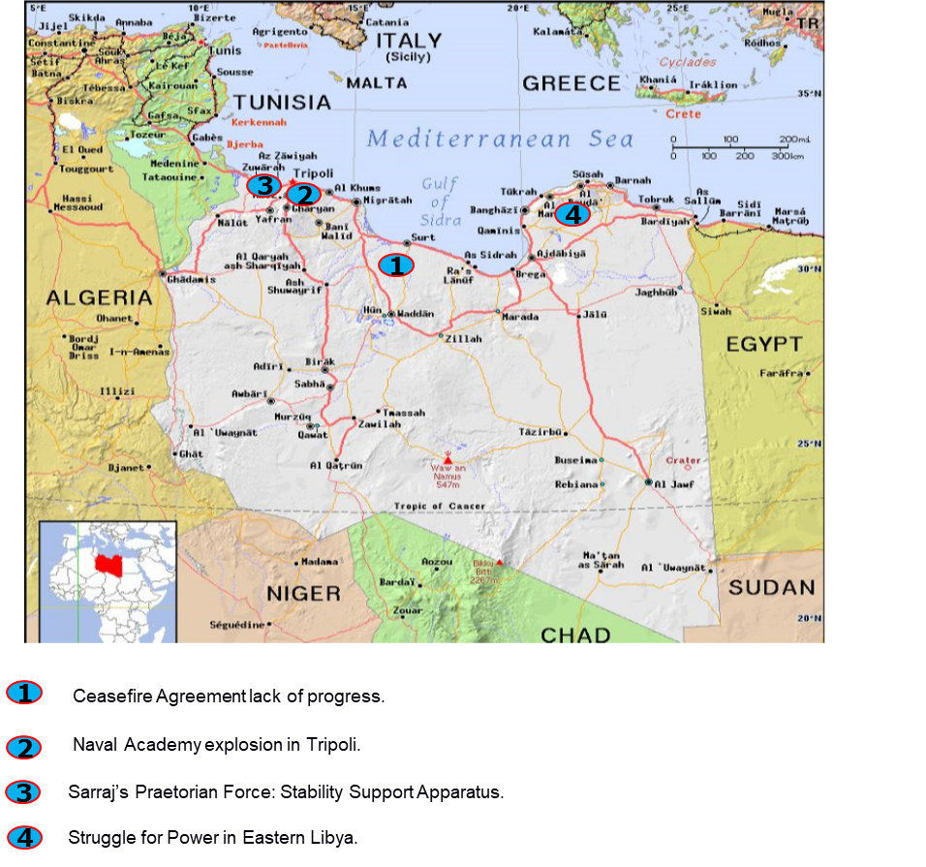

**BLUF: Standing by situation defined the calm situation while the limit for the Ceasefire Agreement is ending. The warring parties have neither time nor desire to withdraw their troops and a new timeframe under 23rd October Ceasefire Agreement is expected but it should include new affordable commitment with a verification mechanism on the field the sooner the better to prevent accidents or tension scalation not expected both in Sirte-Jufra frontline and blurred Fezzan Region.**

1. **General remarks and current tactical situation**

The military track is standing by while the limit signed in the Ceasefire Agreement last 23rd October with no retreat of armed units from their entrenched positions and no signs of foreign mercenaries’ redeployment. The increase in logistic accumulation in both factions’ main bases could be verified and continues as previous weeks.

## Al-Sarraj's Stability Support Apparatus[1].

GNA Prime Minister Fayez Sarraj has established a new security unit called the “Stability Support Apparatus” (National Security). The unit will reportedly be headed by Abd Al-Ghani al-Kikli (aka Ghneiwa) who currently heads the Central Support Department (Abu Salim Central Security Brigade). He will have as deputies:

Ayoub Bouras[2] (commander of TRB, Tripoli Revolutionary Brigade),

Hassan Bouzreiba[3] (Zawiyah) and

Moussa Masmous[4].

Its primary missions should be to protect state institutions, headquarters as well as officials (bodyguarding).

They could also take part in security operations such as:

* + 1. Participation in “implementation of combat operations”, including raids and security operations, as well as executing legal decisions, such as “arrest and prosecution” of wanted persons.
    2. Acting as riot control and deterrent against armed group clashes in “Libyan cities and villages”.
    3. Creating a culture of “non-recourse to weapons”, settling disputes through judicial, security, and social bodies, and supporting programs for collection of unlicensed weapons.
    4. Security cooperation and information exchange “with all relevant security agencies”.
    5. Any other tasks assigned by the PC.

**COMMENT**: Sarraj previously appointed Lofti al-Hariri, one of Ghneiwa’s commanders, as the deputy director for the Domestic Intelligence Services in September 2020. Ayoub Aburas has links to Osama Jweili, head of the Western Military Region (GNA) but also to the Ministry of Interior, likely a strategy of diversification to protect TRBs future. The Abuzriba’s also have links to Jweli. The Minister of Interior, Fathi Bashagha has openly stated his intent to lead a new government, placing him in direct competition with Sarraj who is now widely been seen to be intent on staying in power.

Some reports said militias are not willing to accept Bashagha's future security vision, which includes dissolving their armed groups.

**ASSESSMENT:** ‘The appointment of Ghneiwa and the establishment of a new unit under Presidential Council direct control, suggest Sarraj is looking to strengthen individuals and groups which are currently seen as outside the Minister of Interior’s sphere of influence, and his Minister of Interior, Bashagha, who is trying strongly to promote himself as new interim Prime Minister while Sarraj looks as he is forgetting his desire to resign the position last October.

This new unit can jeopardize Bashagha's intent to launch the very mediatic operation Snake Hunting against smugglers, migrant traffickers and extremists, supposedly Western to Tripoli. This is a clear intent to use armed forces to force an end state in the personal struggling for power inside GNA leaders.

It is most probably the clashes and influence/media operations within GNA leaders and factions will continue or even increase till Political track initiatives make the final photo of charges and new power system. They most probably will continue using armed forces and security structures to bargain and play their cards in the game. It is less probably to expect neither GNA monopoly of armed power nor retreat of foreign armed forces in such this scenario.

## Struggle for Power in Eastern Libya.

### Increased Number of LNA Militia Clashes and Targeted Assassinations.

There were several incidents in Eastern Libya which rise up the insecurity to resembled levels of Western Libya. Those are in the last week the followings:

On 15 January.

Benghazi:

A body was recovered from the beach next to Seville hotel. The body was handcuffed and had suffered gunshot wounds.

In Sulmani an RPG impact was reported.

An unidentified individual was shot and killed in the Sarti area.

Derna: An individual was stabbed and killed maybe due to a personal dispute.

Tobruk:

Small Arms Fire was reported from the area of Liberty buildings near the port area and in the Tobruk Oil Institute.

An individual was shot and killed.

On 20 January in Benghazi, the body of Kamal Al-Amami, a businessman, was found in Al-Zait Street days after he was reported to have been kidnapped. He was found along with three other bodies. All bore signs of torture and bullet wounds.

**COMMENT:** For months, it was a fact the inexistence or the secrecy to reveal any Eastern Libya problems between militias, its tribes and the stablished security forces under strong control of Marshall Haftar. This situation is evolving to mirror Western intra militias tensions.

### LNA Commanders attempt of assassination

Attempted assassinations of LNA commanders have continued to be reported with the attempted assassination of Issa Dhaoud Al-Qabsi, said to be a commander of LNA Saiqa Special Forces 302 Battalion, being reported in Benghazi on 15 January.

**COMMENT:** There were supposed failed assassination attempts against senior LNA commanders, with similar pattern such as the one against Hassan Maatouk, the commander of the LNA’s 128th Brigade in Hun on Dec 25 and another important leader from Umm Al Aranib Martyrs Brigade Commander, Al-Mandi Baraka Kusu Muhammad, south of Qatrun on Jan 07.

The LNA cohesion in a post-conflict Libya and after the June 2020 defeat have been some of the underlying concerns with regards to stability in the east and south of the country.

The loyalty of many groups to Operation Dignity was contingent on the delivery of certain rewards from Haftar, none of which have subsequently materialised. Furthermore, the lack of a unified focus of effort with no enemy and the perception of Haftar's declining star may see an increase in groups, nominally under the control of the LNA, branching out to increase their territorial or political footprint prior to any negotiated settlement, where Haftar's family could be seen as another in competition for the resources and the smuggling routes as several reports indicate.

**ASSESSMENT:** Those two attempted assassinations, only first line leaders (the most loyal to Haftar) with neither trustful visible victims nor any independent report, have enabled the LNA to impose justified security measures on their areas, with greater centralized control.

The reason why LNA wants such this increased control could be rationalize in two ways:

1. Hypothesis of an information operation to justify tight control and reaffirm the need of strong LNA and so, the Haftar's supporters’ survival. It is based on the fact that this centralized security has apparently less result in preventing the criminality and the victims of assassinations with signals of inhuman torture, in the way of organized crime messaging within the infight between Eastern militias, tribes, factions or even Armed Forces near to Haftar's most loyal ones.
2. Hypothesis of disunity within LNA. Opposite hypothesis is to consider the assassination claims could be true, giving us the assumption that the frequency would be indications of increasing internal friction within both the LNA and tribe militias, who previously accepted loyalty to Haftar; and the effect, as in the first hypothesis, of increased number of clashes and inter clans’ assassinations.

It is likely first hypothesis could be the most reasonable one because the tight control of media when LNA desires and these campaigns of insecurity are perfects to promote Haftar's options again. We can expect likely a continuation of the violence in Eastern Libya, with mediatic security operations of LNA afterwards in those areas.

## Ceasefire Agreement Achievements. Time Limit to Expire

The UN chief, Antonio Guterres, urged last 20 January, the departure of all foreign fighters and mercenaries from Libya by Saturday as called for in the October 23 ceasefire agreement signed by the warring sides.

All foreign fighters were to have withdrawn from Libya by January 23 as per the October ceasefire however current indications are that neither side are planning on adhering by the clause.

### Mercenaries returns.

The Syrian Observatory for Human Rights (SOHR) claims that 95 Syrian mercenaries in Libya have returned to Syria while a further 200 have been deployed in. If so, this would reportedly be the second batch of returning Syrians after Turkey suspended repatriations in November 2020, according to SOHR. Forty returned last week with some reports claiming that they had paid for false medical certificates in order to secure their discharge.

On 21 January, an American journalist has claimed that the Syrian National Army in Idlib is preparing to send more fighters to Libya. A thousand men from the Hamza Division and a newly formed Hamza splinter group are allegedly at a pre-Libya training camp in Antakya, Turkey.

Reports suggest multiple Sudan Liberation Army (SLA) convoys have left Libya for Sudan over the past few weeks due to the Juba peace agreement signed on 31 Aug 2020. The reports suggest SLA convoys have gradually retreated from the central Jufra district and other positions under LNA control in Libya. Others have reportedly remained in Libya; it could be the Janjaweed.

There are independent facts that maintain the respective bands logistic flights:

On 16 Jan 2021 at 16:15 UTC, Russian Air Force Tupolev Tu-154 disappeared in the airspace of eastern Libya and was expected to land at Al-Khadim Air base coming from Damascus. The plane took off from Moscow to Syria for two hours and then left for east Libya.

**COMMENT:** Conflicting reports over unconfirmed Libyan National Army (LNA) downing of two unmanned aerial vehicles (UAV) in the area West of Sirte. Pro-LNA sources share alleged image of a downed UAV; however, sources confirm that the image is of a CHILONG 11 (CL-11) VTOL UAV downed in Tarhuna in September 2019, undermining the validity of pro-LNA claims. Localised sources confirm sounds of weapons near LNA-controlled Ghardabiyah Airbase, with speculation of LNA/ external force weapons training.

There were a United Kingdom RAF C17 Globemaster flight, departed from Brize Norton AB, landing on Misrata. First time of such this flight from UK.

**ASSESSMENT:** It is likely the logistic support and movement of mercenaries will continue mainly from Syria. Both external stakeholders, and many tribes and militias are comfortable in this scenario of Status Quo, where they have a win-win approach to divide Libya in areas of control for each band.

## GNA Naval Academy Explosion

On 19 January 2021, in al-Sayad west of Janzour city, a fire reportedly erupted in the storage of the Naval Academy which led to an explosion. Further information indicated that the explosion was caused by old ammunition stored in the place.

The academy's commander Ahmed Ayub, and Naval College commander Salem abu Salah together with another civilian (IDP) were reportedly killed in addition to the injury of five other civilians residing in the vicinity of the Academy. The event would have been caused by a fire.

**COMMENT:** It is an estrange accident that kills two high ranking officers by an accidental explosion. Investigation should be mandatory.

## Inherence of GNA Armed Group into Political Talks.

The Tripoli Protection Force (TPF) has rejected the agreement on the mechanism for appointing a new executive authority by the LPDF. They urged Libyan parties to turn to Libyan-Libyan dialogue as soon as possible citing the “personal interferences of some UNSMIL members in redirecting the political track into some rhetoric that isn’t useful for all Libyans.

**COMMENT**: ‘The TPF was established in 2018 after the Kani/ Badi offensive on Tripoli as an umbrella group for Tripoli Revolutionaries Brigade (TRB), Nawasi 8 Force, Bab Tajoura Brigade and the Abu Salim Deterrence and Rapid Intervention Force (Ghneiwa).

The TPF represents the core of armed groups which are currently assessed to be aligning with Prime Minister (GNA) Fayez Sarraj who in turn has been rumoured to be considering announcing his own new interim government. If so, the TPF’s rejection of the recent progress on the political track with the LPDF could be seen as another indicator of Sarraj’s possible agenda.

**ASSESSMENT:** It is likely the Prime Minister Serraj could increase his loosed footprint to renew him in his charge with the use of all influence methods, being the manoeuvre and coercion of this TPF armed group and the new Stability Support Apparatus to boost his options and desires, now in clear opposition to Bashagha's.

**CONCLUSIONS**

Timeline stablished in the Ceasefire Agreement last 23 October for the retreat of foreign armed forces, mercenaries and the garrison of contact troops in Sirte frontlines and the reopening of land communications are still pending on just one success, it could be next days 5+5 Military Committee meeting could be the last opportunity to relaunch the Military Track pioneering the rest to gather concrete results and a most likely new timeframe to a postponed agreement, most likely to maintain Status Quo of tiny advances while maintain separate areas of influence where Turkey and Russia stakeholders will win their own avoiding scalation but enough warring rhetoric to justify their respective inherence in Libyan affairs to obtain their expected reward for their support.

The following month will be key to success or to step backward to weapons speech if any miscalculation of possible clashes happens in the contact areas, while decomposition of state centralized power will be dissolved in armed groups feudal clashes, in both sides. That would benefit militias and tribes’ desires of   
short-termism villager profit.

**2. Update military events**

In addition to the points above, some events could be mentioned:

* On 15 January, an increase in LNA security operations in the southern region has been noted over the last 48hrs. VCPs were reported in the Ghat, Tahala, Adiri and Umm al-Aranib areas. Much of the reporting is derived from LNA information sites and may be related to the LNA’s recent increase in rhetoric, framing it as a force of stability and security in the south.
* On 16 January, Russian Air Force Tupolev Tu-154 RA-85042 was expected to land at Al-Khadim Air base coming from Damascus. The plane took off that day from Moscow to Syria for two hours and then left for east Libya. He was flighting without electronic identification system activated.
* On 16 January various sources including U.S. AFRICOM confirmed the permanent deployment of Sukhoi Su-24 fighters at Al-Khadim [A](https://twitter.com/hashtag/Libya?src=hashtag_click)ir Base.
* On 16 January, in Ghardabiya Airbase (south of Sirte) – it was detected some fires of standard Pantsir and other unidentified "modern weapons" testing, possibly shooting down of 2 GNA UAVs but not confirmed (InfoOps) and some alleged clashes between Russian & Sudanese mercenaries over money issues.
* On 16 January in Zliten, Al-Murqub Province, Yusef Bin Hariz was killed by a member of the Qrayba family. It was followed a revenge next day, 17 January, by Bin Hariz family on the Qrayba family using multiple weapon systems.
* On 18 January, in Qasr Al-Hajj, Al-Jabal Al-Gharbi Province, The General Administration of Central Support carried out a security operation including VCPs.
* On 18 January, localised sources report a GNA/ LNA prisoner exchange set to take place in Ash Shwayrif area.
* On 21 January in Hamza Camp,Tripoli Province, Small Arms Fire was reported. The area sits on a current fault line between 301 Battalion and Central Support Department (Abu Salim) with tensions persisting however local reports suggest that the SAF was connected to either a wedding or a celebration by Central Support Department members (Ghneiwa).

1. Some translations stated this force with the name of “Stabilisation Security Agency”.
2. Written in some reports as Ayoub Aburas or Ayoub Abu Ras.
3. Written in some reports as Hassan Abuzriba or Hassan Abu Zariba.
4. Written in some reports as Mousa Mahmoud.