MATERIAL | DESCRIPTION | UNIT COST (VALUED) | N. of ITEMS | EXPECTED COST FOR COURSE INSTALLATION
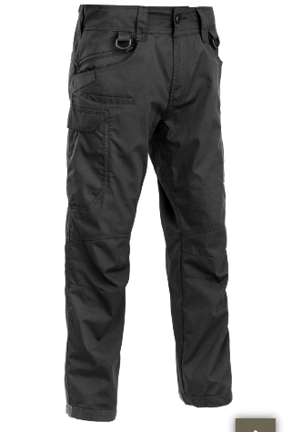 | Combat pants: Defcon Predator | 60 euro | 10 | 600 euro
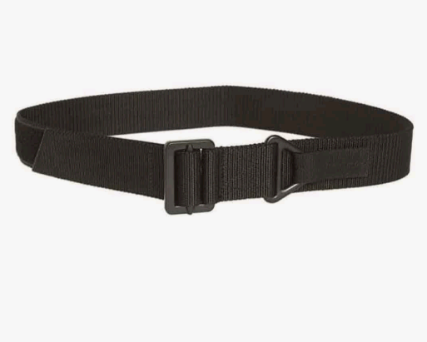 | Rescue belt: Miltec rigger | 15 euro | 10 | 150 euro
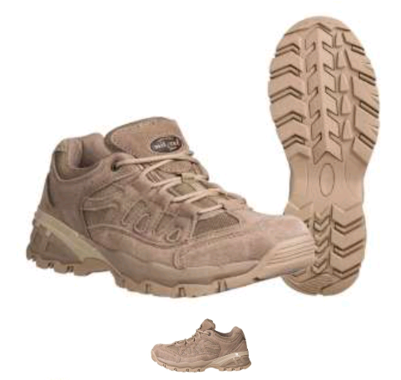 | Desert boots: Miltec squad 2,5 inch | 60 euro | 10 | 600 euro
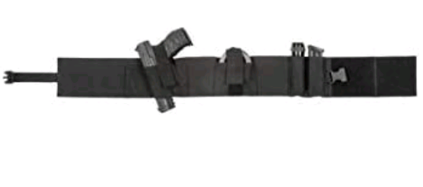 | Elastic tactical band: Vega Holster 2ET21 | 25 euro | 10 | 250 euro
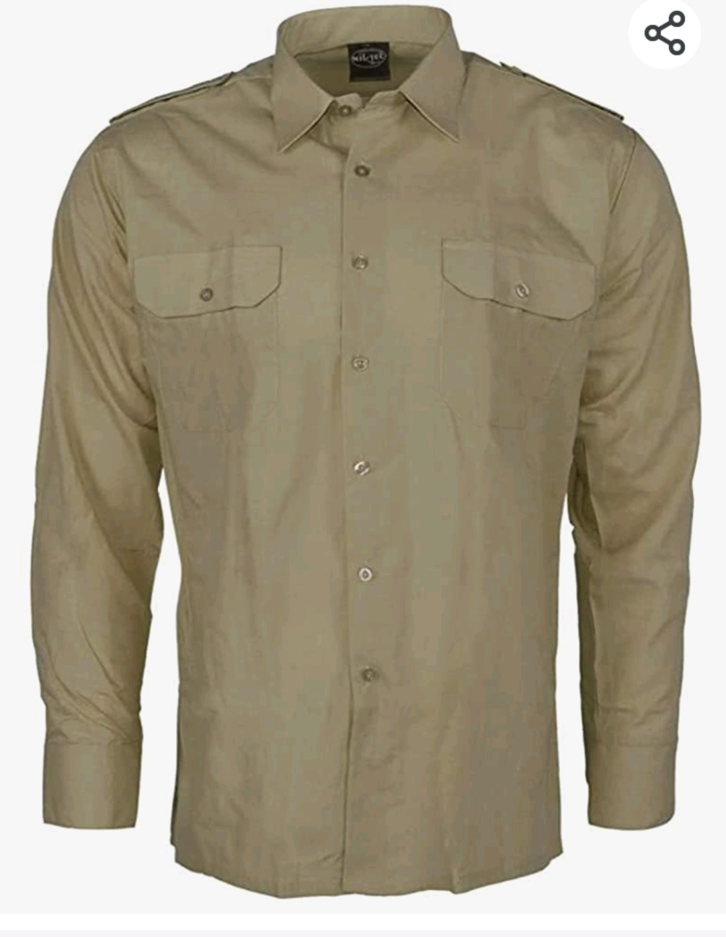 | Ripstop shirt: Miltec | 30 euro | 10 | 300 euro
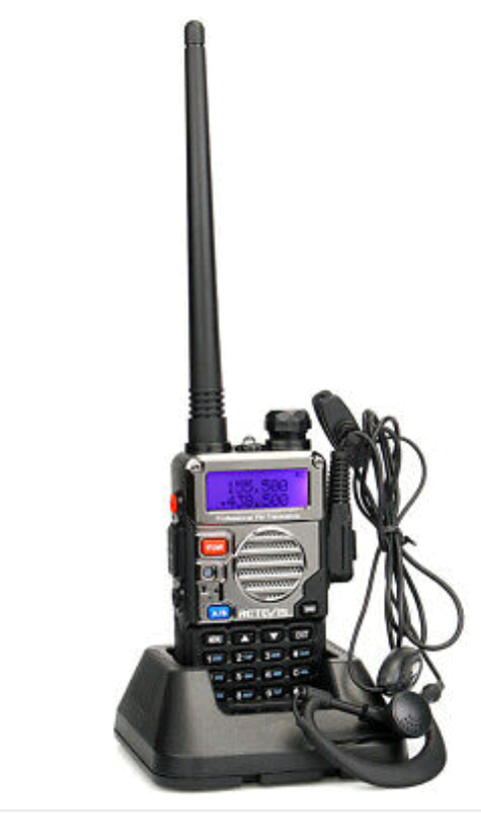 | V/UHF Portable radio with headset and battery charger: Retevis RT 5 RV | 40 euro | 10 | 400 euro
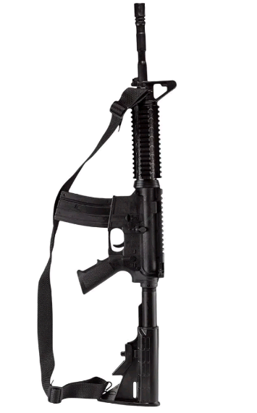 | TRAINING RIFLE M4  (EQ 004) | 200 euro | 10 | 2000 euro
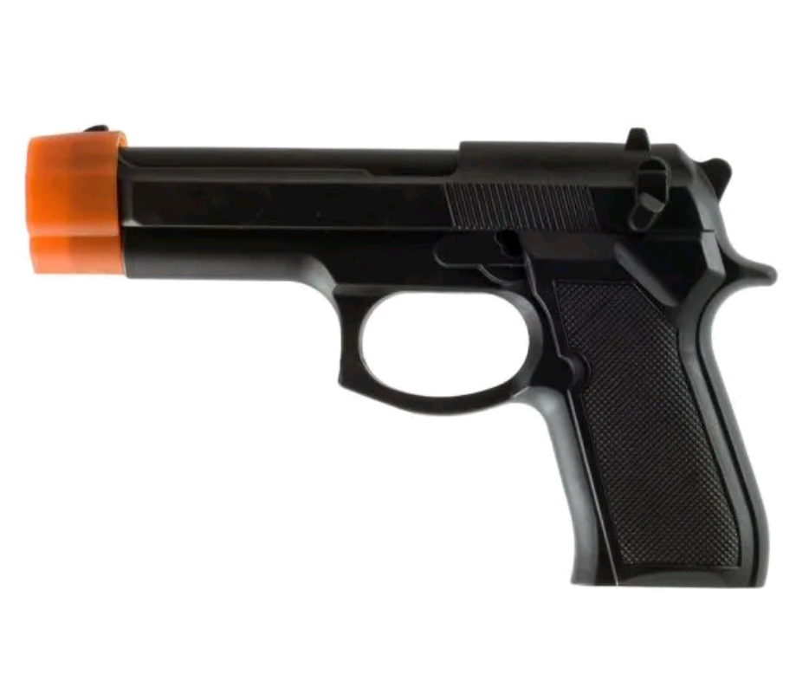 | TRAINING PISTOL BERETTA  (EQ 001) | 20 euro | 10 | 200 euro

