18/10/2021



**ITALY-LIBYA JOINT MILITARY COOPERATION**

**CONVOY ESCORT COURSE**

**OBJECTIVES**

!

***L***

*i*

|  |  |  |  |  |  |
| --- | --- | --- | --- | --- | --- |
| IMPROVE PLANNING |  |  | INDIVIDUAL-VEHICLE |  | EMERGENCY & LOGISTIC |
| CAPABILITIES: |  |  | TASK's |  | CONTINGENCY |
|  |  |  | MOBILITY TTP' s |  |  |
| TERRAIN ANALYSIS ROUTE PLANNING HOW ORGANIZE CONVOY ESCORT EXPLOIT MOST LIKELY ANO MOST DANGEROUS ENEMY **C.O.A.** EXTERNALSUPPORT UNIT.(IED-AIRSUPP) |  | •:• | MISSION COMMANDER VEHICLE SETUP  RECONNAISSANCE VEHICLE  ANTI-AMBUSH DRILLS |  | VEHICLE FAILURE DRILLS;  IED ATTACK REACTION;  TACTICAL EMERGENCY CASUALTY CARE; |

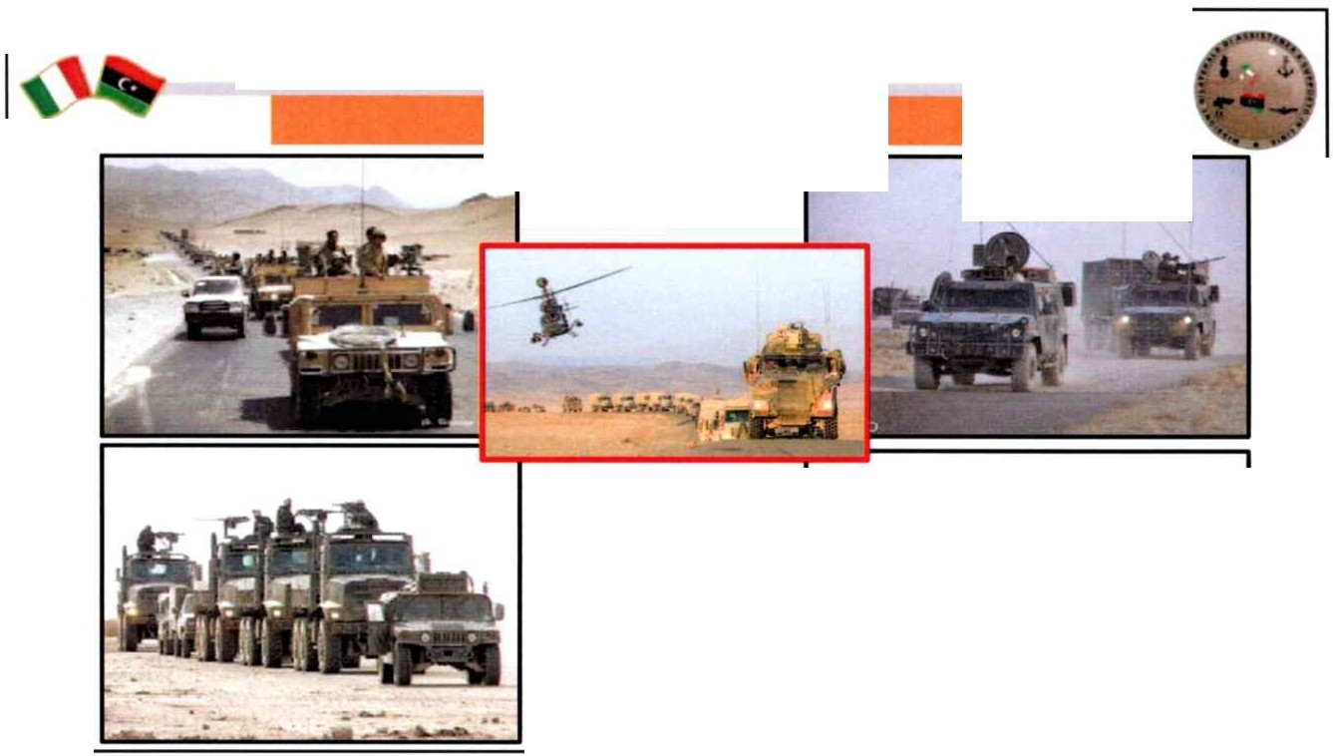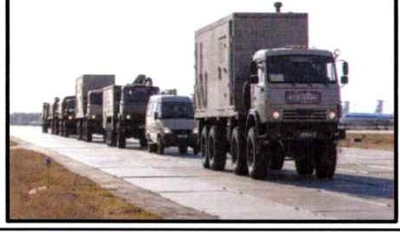

**ITALY-LIBYA JOINT MILITARY COOPERATION**

**CONVOY ESCORT COURSE**

IDURATION 24HI

I TRAINEE 6-10 I

!VEHICLE M in n°3 **j**

1

## CONVOY ESCORT COURSE

**GENERAL OUTLJNES**

The course is designed to present skills for the attendees who will operate inside a convoy escort team, permissive and non permissive environment. Attendees will train in skills that will improve their basic and advanced mounted drills, driving skills and reactions to different typ es of possible attacks on the convoy in hostile environments

## OBJECTIVES

The course is designed to develop skills for the attendees to provide escort to the convoys in a tactical environment.

Topics of the course:

* vehicle selec tion;
* protective driving;
* sabotage;
* combat convoy;
* basic radio operators drills;
* complex attack;
  + convoy drills;
* weapons drills (carry inside vehcle, shooting through glass ... );
* use of cover;
* anti-ambush drills;
* IED (attacks, react ions, procedures);
* MEDEVAC;
* Post rnission, debriefing.

## CONTENTS

|  |  |  |
| --- | --- | --- |
| **CONVOY ESCORT COURSE** | Theoretical module includin g:   1. Generai convoy organization and composition 2. Equipment and communication procedures 3. Escort Team rnemb ers assigned tasks 4. Different procedures m the event of accident, mechanical failure and enemy   ambush | 7 hours |
| Practical trainin g on different tec hniques and procedures discussed during the above lessons | 1O practica l periods |
| Final exam | 7 |
|  | 24 hours Total |

**METHODOLOGY**

The course will be taught us ing theoretical and practical exercises. The lectures will be conducted in the classroom, on roads and on the training range.

## MATERIALS

Persona! military equipment/civilian clothes appropriate for climate and conditions; Man-portable and vehicle radio equipment;

Soft skin / armoured civilian or military vehicles (minimum 3).

# DURATION

24 hours totals including the final e xam.

# ATTENDEES

To be ag reed with Libyan counterparts (6 + 12 participants).

# TRAINERS

CPT instructors/o perators wit h experie nce in operational activities.